
LITTLE FLOWER CONVENT HR. SEC. SCHOOL
Opposite Capital Mall, Narmadapuram Road, Misrod Bhopal-26. (MP)
Affiliated to MP. BOARD, Affiliation No. 632437
Email – littlefloweragp@gamil.com, www.littleflowerschoolmisrod.com

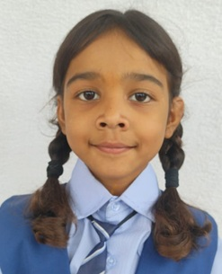
RECORD OF ANNUAL ACADEMIC PERFORMANCE

2025-26
Name of Student : ANANYA SHARMA
Father’s Name : Mr. Lokesh Sharma
Mother’s Name : Ms. Priya Sharma
Date of Birth : 06.11.2018 Class: I - Sec: A Scholar No: 1329
SCHOLASTIC
SUBJECT | UNIT TEST |  | I TERMINAL |  | II TERMINAL |  | ANNUAL EXAM |  | ANNUAL  AGGREGATE
SUBJECT | Max | OBT | Max | OBT | Max | OBT | Max | OBT | (Grade)
English | 40 |  | 100 |  | 100 |  | 100
Hindi | 40 |  | 100 |  | 100 |  | 100
Mathematics | 40 |  | 100 |  | 100 |  | 100
EVS | 40 |  | 100 |  | 100 |  | 100
Grand Total | 160 |  | 400 |  | 400 |  | 400
Percentage %

NON SCHOLASTIC
CO-CURRICULAR ACTIVITY |  |  | PERSONAL ATTRIBUTES
Computer |  |  | Punctuality & Punctuality
Cultural Activity |  |  | Neatness & Cleanliness
General Knowledge |  |  | Discipline & Responsibility
Art & Craft |  |  | Leadership Quality
Sports |  |  | Overall Development
HEALTH ASPECTS |  |  | ATTENDANCE
Height (in cm) |  |  | Total Working Days
Weight (in kg) |  |  | Total Days Attended
Physical Development |  |  | Percentage of Attendance
Division: - |  |  | Date of Issue: -
Remark: - |  |  | School Reopen On: -
 |  |  | Principal
Result: - Pass & Congratulations! Promoted to Class 2nd
Teacher’s Signature | Parent’s Signature

